Appendix A

**> install.packages("foreign")**

**> require(foreign)**

**> unionData <- read.dta("http://www.sfu.ca/~cmuris/2014-Summer-333/wagepan.dta")**

**> unionData <- na.omit(unionData)**

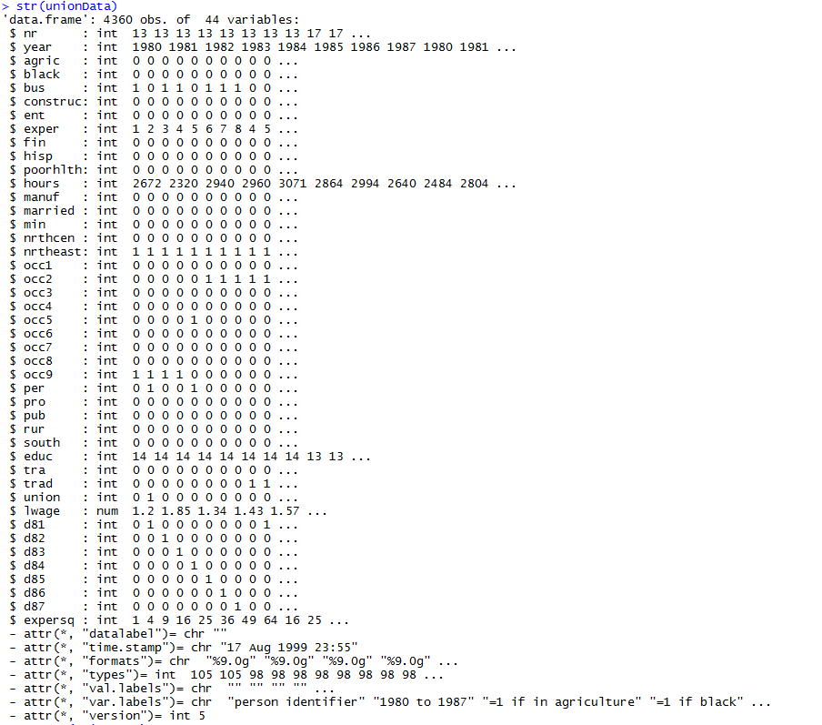

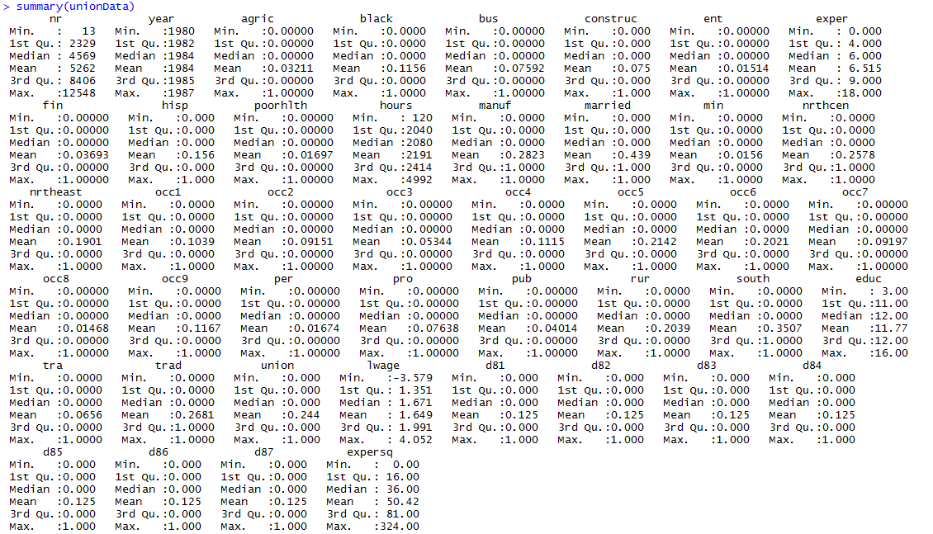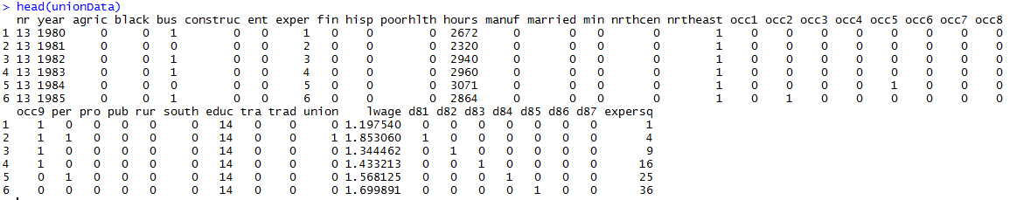

Appendix B

